2019上半年中小学英语教师资格证面试真题及答案
一、考题回顾
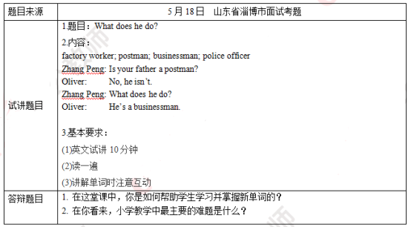
二、考题解析
【教案】
Teaching aims:
Knowledge aims:
Students can master the meaning and pronunciation of the new words, “factory worker, postman, businessman, and police officer”.
Students can learn the sentence structures “What does he do?/ He’s a businessman.”
Ability aim:
Students can ask and talk about career with the new words and the sentence structures in daily life.
Emotional aim:
Students can be interested in learning English and cultivate the awareness of career and the spirit of cooperation.
Key and difficult point:
Key Point:
Students can master the meaning and usage of the new words and sentence structure.
Difficult Point:
Students can improve the interest of learning English and cultivate the awareness of career and the spirit of cooperation.
Teaching procedures:
Step 1: Warming-up
1. Greetings. Talk about the weather.
2. Sing a song for students.
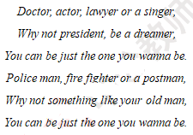
Ask them if they can figure out some different careers in this song, and they may say “doctor, actor, and singer”. Then tell them that today we are going to learn more new words about career.
Step 2: Presentation
1. Present the words and teach
Draw some pictures according to the different words and describe them simply, and then teacher shows the words to the students and reads them.
2. Present the sentence
Read the conversation for the students. Ask them to listen carefully and find which sentence is used to ask others’ career and what’s the answer. Write them down on the blackboard. Then ask student to do an exchange exercise using the words learned before and the sentence patterns.
—What does he do?
—He’s a businessman.
Step 3: Practice
Do the guessing game. Ask students to guess the words that the teacher is acting.
Step4: Production
Ask students to do a role play and try to make new dialogues with their desk mates according to new words. 5 minutes will be given. Then invite 2 pairs to share their dialogues and give encouragement.
Step5: Summary and Homework
Summary: Teacher summarizes the whole class.
Homework: Ask students to tell their parents what they have learned in school today and talk about their career with the sentence structures.
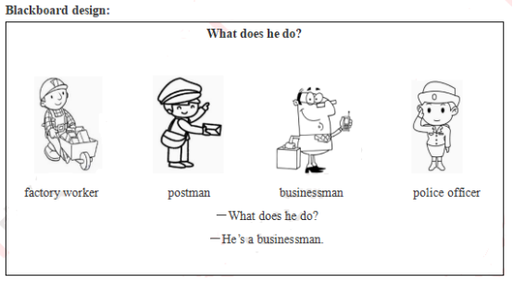
【答辩题目解析】
1. How did you help students learn and master new words in the vocabulary class?
【参考答案】
In a word, I make use of funny and vivid pictures to teach the new words. First, I draw some pictures about the new words on the blackboard and use simple sentences to describe them. Second, I lead students to try to tell me the word for each picture and then give them the right answer. So students will know the meaning of these words by this vivid method. Third, I ask students to read these words after me, so they can know and learn the right pronunciation. What’s more, students can practice and consolidate the new knowledge by the next few activities. So I believe they will really learn and master the new words.
【答辩题目解析】
2. What’s the mainly difficulty in primary school teaching in your view?
【参考答案】
In my view, I think the main difficulty in primary school teaching is that pupils are easily distracted by something else, and they only can remember the new knowledge for a short time. So teachers should pay attention to their features, and take positive and active measures for that. We can make use of funny games or activities to help students memorize and consolidate what they have learned timely, and review the knowledge regularly.

